Greenhouse Fertigation SOP
How to hook up the Dosatron:
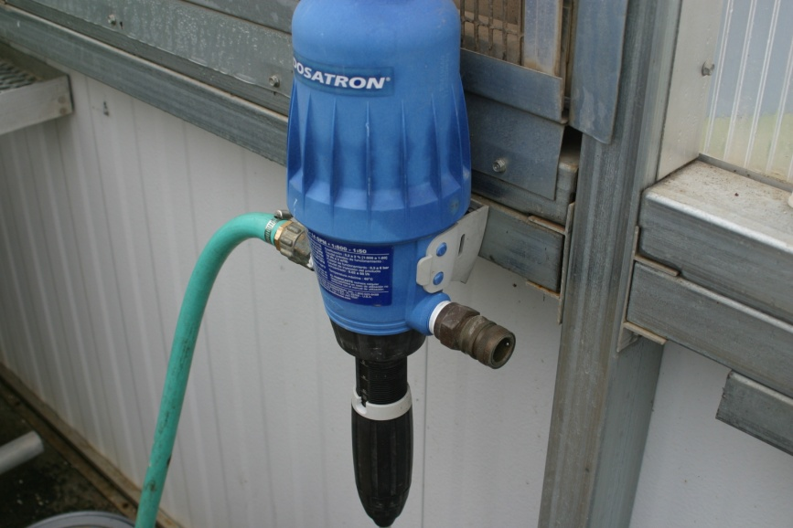
The green hose should be attached to the left side of the Dosatron and it should be connected to the second faucet (the one with the red tape above it). Generally, this part should already be hooked up. Then unhook the yellow hose from the faucet marked “clear” and attach that hose to the right side of the Dosatron.
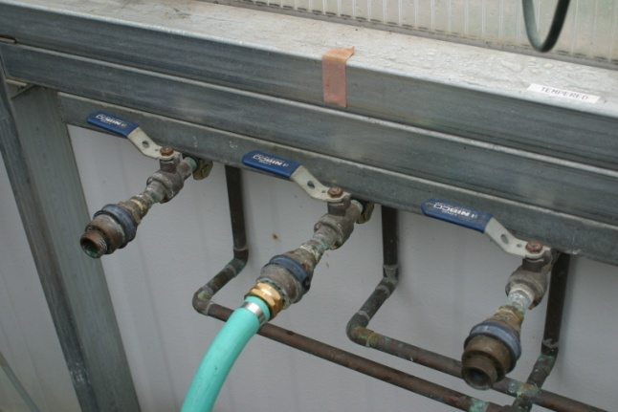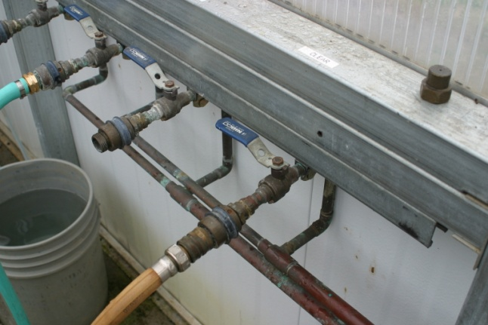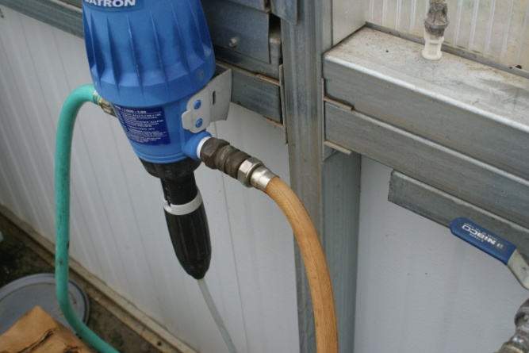

How to set the dilution rate:
On the bottom of the Dosatron is a black piece that is screwed in or out to adjust the dilution rate. Choose what rate to fertigate and adjust the black piece up or down. Where the little arrows point is what the rate will be set at.
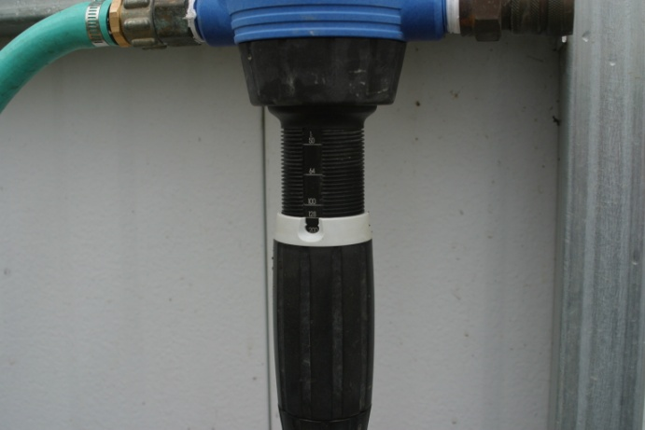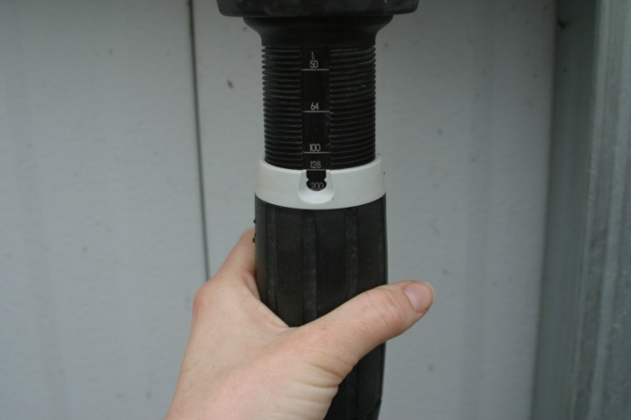
Once the rate has been set, shake the fertilizer container (Nature Source) to mix the contents. There should be a clear tube coming from the bottom of the Dosatron. Place that tube into the fertilizer container. After everything has been hooked up, turn on the faucet that the green hose is attached to (the one with the red tape above it).
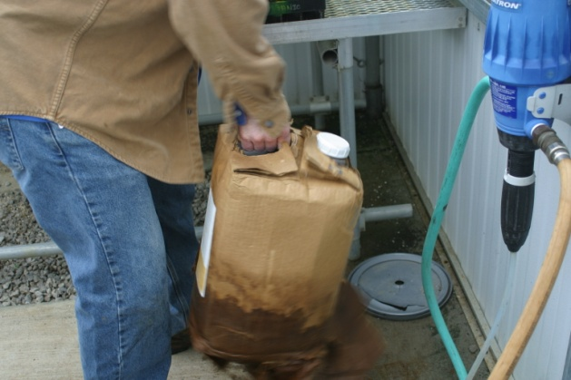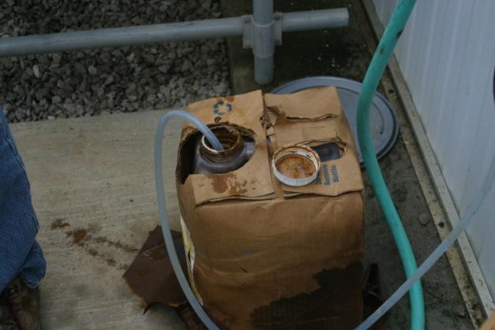
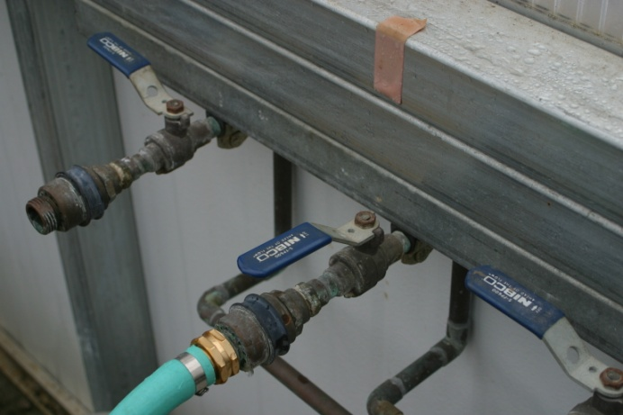

Hold the watering wand over the rocks or concrete and let the water run through it. You will start to see the fertilizer being pumped up towards the Dosatron and eventually the water coming from the wand will start to have a brownish tint to it. This will take a few minutes. You can also smell the water coming out and be able to tell if there is fertilizer in the water.
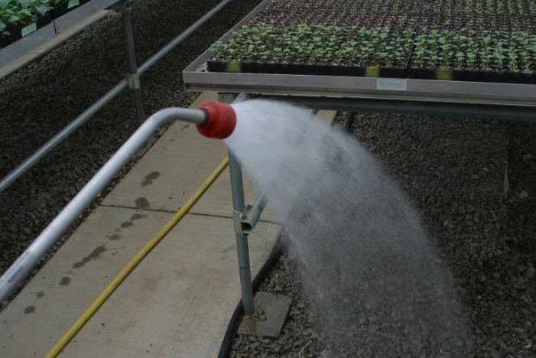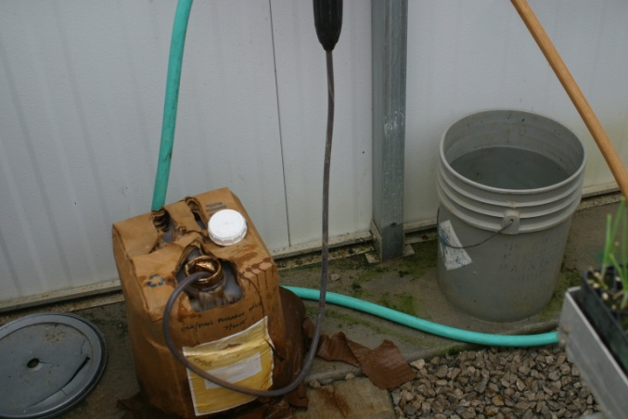
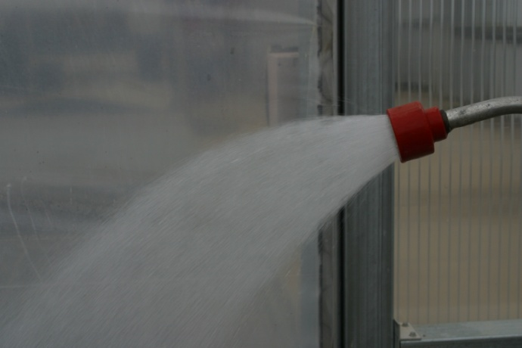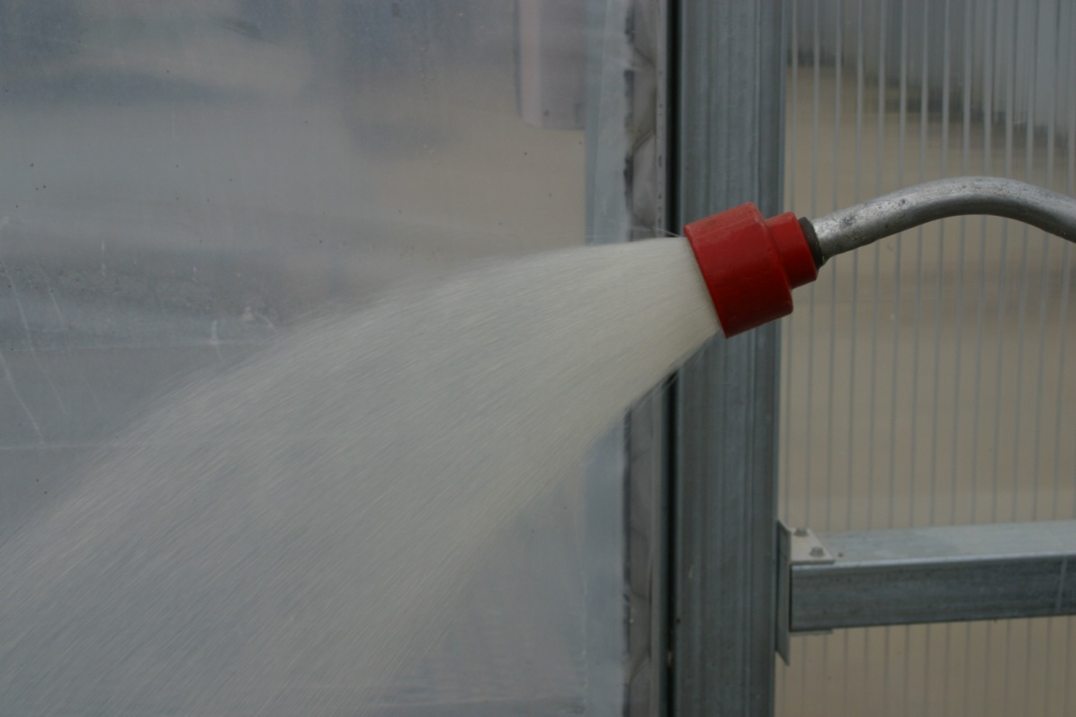
The brown tint from the fertilizer
Before the fertilizer reaches the wand

Water the plants that need to be watered.
To water taller transplants:
Water, holding the wand to the side so that the water spray is coming in near the base of the plants. Go up and down the sides of the trays, making sure you get each side and the front and back edges.
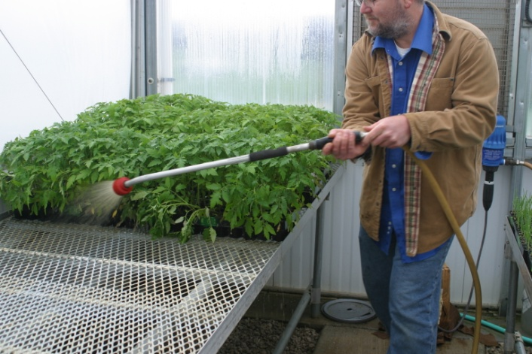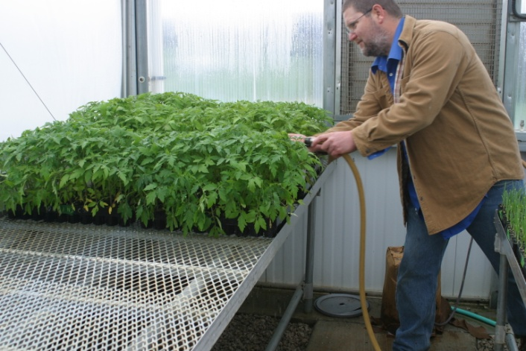
To water smaller transplants:
Hold the wand above the trays. Make a slow pass from one end of the tray to the other, ensuring that the edges are watered as well.
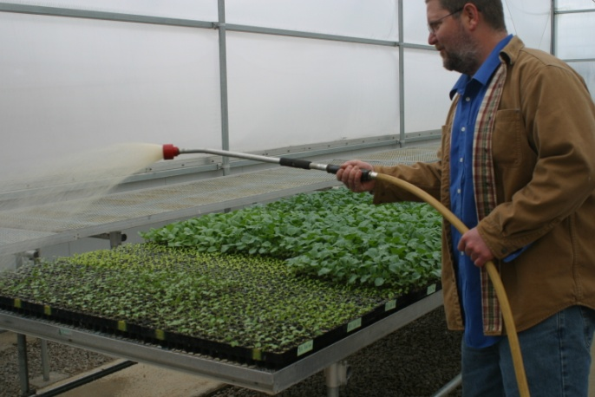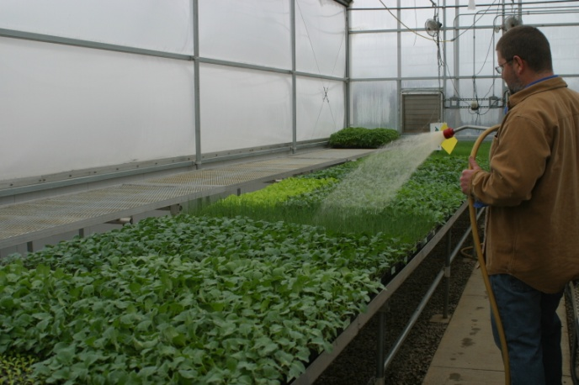
Once you have finished fertigating the plants. Turn the green hose faucet off (the one with the red tape above it) and unhook the yellow hose from the Dosatron and hook it back up to the faucet marked “clear”.
Rewater all the plants that have been fertigated to prevent foliar burns on the leaves of the plant, following the same motions as you did for fertigation.

Cleaning the Dosatron
After the plants have been rinsed off, the Dosatron line needs to be cleaned out. Turn off the faucet marked “clear” and rehook the yellow hose to the right side of the Dosatron. Take the clear tube out of the fertilizer container and place it in the bucket of water beneath the Dosatron. (If the bucket does not have clean water or enough water in it, dump it out and fill it up first). Turn on the green hose faucet and hold the wand out over the rocks or the concrete. Let the clean water run through the hose for several minutes to ensure it has been cleaned out. To speed up the flushing process, you can adjust the dilution rate back up to the smallest rate. After the line has been rinsed out, turn the green hose faucet off and move the yellow hose back to the faucet marked “clear” and release any pressure in the hose.
