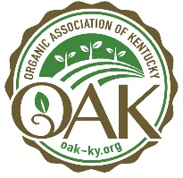 **ORGANIC ASSOCIATION OF KENTUCKY’s 11th Annual Conference**

*Sowing the Seeds for Healthy Soils, Resilient Farms and Thriving Communities*

**Virtual Conference: January 27-29, 2022**

**In-person Conference at Christian County Extension Office: March 18, 2022**

**In-person Conference at Boone County Extension Office: April 8, 2022**

Dear Friend,

We hope you will join us for the 11th Annual Organic Association of Kentucky Conference Series, *Sowing the Seeds for Healthy Soils, Resilient Farms and Thriving Communities*.

**OAK Conference 2022 offers virtual and in-person events!** The virtual conference is 3 days of live sessions, with recordings available for viewing up to a year after the event. The in-person 1-day regional conferences will take place in Christian County (Hopkinsville, KY) and Boone County (Burlington, KY) with a full day of programming and lunch. Join the regenerative organic agriculture community for deep learning and networking. Last year’s virtual event was spectacular, and we are expecting high regional engagement with the expanded access that comes from a virtual conference and regional in-person events. All Sponsors and Exhibitors receive registration and a large online presence with attendees.

This is a unique opportunity to promote your business at Kentucky’s annual organic agriculture event that draws more than 450 attendees. Network with farmers eager to learn about regenerative organic agriculture and share information about your products and services with this target audience. When you sponsor or exhibit at the conference you are supporting the industry and building meaningful connections with this expanding network of farmers, local food advocates and agriculture professionals. Register early to be included in pre-event promotions and SAVE; exhibitor registration increases $50 after November 1st.

**SPONSOR and receive maximum exposure**

* Choose from five tiers. Includes extensive pre-to-post event business promotions.
* Virtual Trade Show profile, abundant promotion on the conference app, pre-recorded video promotion.
* Booth at in-person event(s) depending on sponsorship level and interest.

**EXHIBIT at the Trade Show**

* Connect with attendees through dynamic networking tools on the virtual conference app. Includes two virtual conference registrations.
* Add on booths for one or both in-person conferences. Space is limited so reserve early.

**ADVERTISE** **in the online event**

* Just want to share a video with attendees? Submit a video up to 15 minutes long.

Do you have questions about what to expect with a virtual conference? We’re here to help! OAK staff will share tutorials on how you can use the conference platform to network with attendees and share your message. Sponsors and Trade Show exhibitors have access to upload videos, offer giveaways, chat with attendees and see attendee profiles.

**Visit the conference webpage for more information and become a**[**sponsor**](https://www.oak-ky.org/sponsor-information)**,**[**exhibitor**](https://www.oak-ky.org/exhibitor-information)**or**[**place a video ad**](https://www.oak-ky.org/advertising-registration)**.**Online registration is available, or if you prefer paper registration just use this form.

It is going to be another fantastic event. This is what past sponsors and exhibitors had to say:

***“Great conference and so many farmer attendees! High-quality and in-depth sessions.”  
  
“Positive experience from the registration process through the conference close. I really appreciated all of the pre-conference communication from OAK staff leading up to the event. Very informative and reassuring.”***

We are excited to work with you to make the annual conference a success for your business and Kentucky’s farmers. Please contact me with any questions at [brooke@oak-ky.org](mailto:brooke@oak-ky.org) or (502) 219-7378. Thanks for all you do to support Kentucky’s unique food and farming movement. See you at the conference!

Sincerely,



Brooke Gentile

Executive Director

**Conference Sponsor Levels**

*Register by 11/1/2021 to be included in all early event promotion!*

**Barn Raiser Sponsor ۰ $5,000 +**

Presenting sponsor receives the most coverage before and during the event.

8 Virtual conference registrations + Virtual Trade Show profile + In-Person conferences + promotions below

**Harvest Sponsor ۰ $­3,000 +**

Be a track sponsor at this level and appear on all related sessions.

6 Virtual conference registrations + Virtual Trade Show profile + In-Person conference + promotions below

**Cultivator Sponsor ۰ $2,000 +**

4 Virtual conference registrations + Virtual Trade Show profile + promotions below

**Seed Sponsor ۰ $1,200 +**

2 conference registrations + Virtual Trade Show profile + promotions below

**Farmer Sponsor ۰ $500 +**

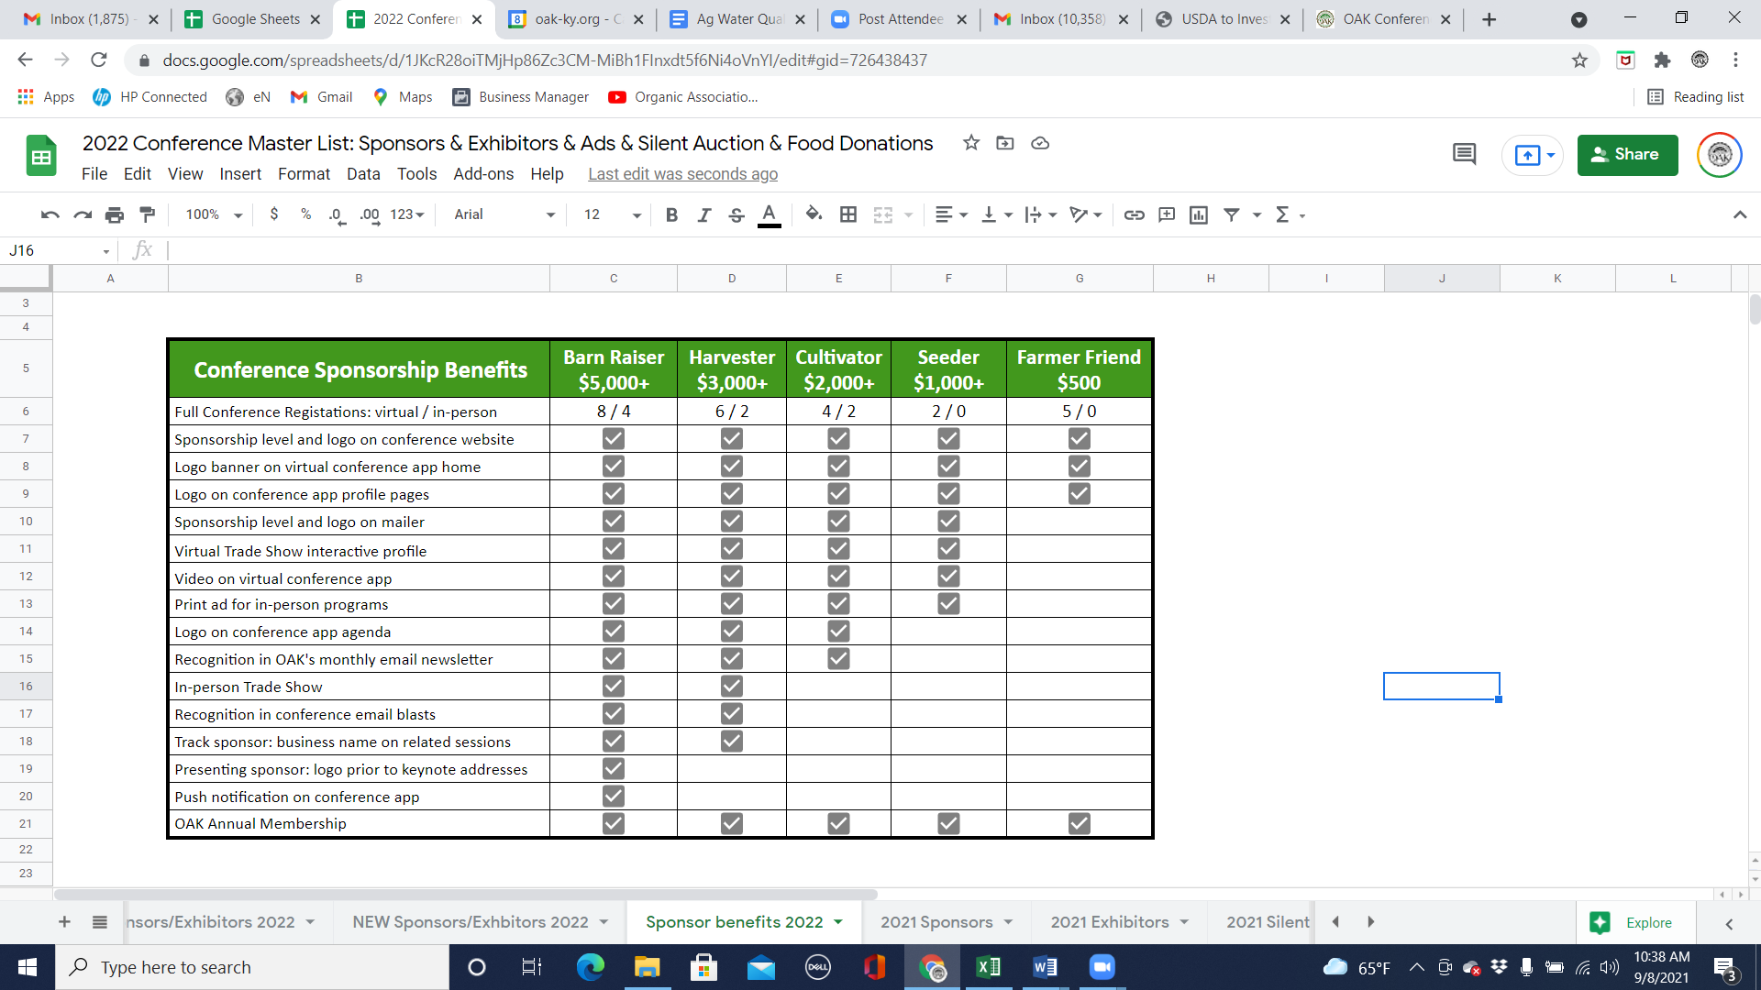1 conference registration for you and 4 others go to Farmer Scholarships + promotions below

**All sponsorship packages include:**

* Recognition at the conference, in the program, promotional materials and website according to level.
* Access to attendees that are organically-minded farmers, researchers and good food advocates.
* Abundant promotion and the opportunity to share your message with attendees.
* Annual OAK membership and a listing in OAK’s online directory.
* Enormous gratitude from the entire farming community!

**Submit completed form with payment or invoice request to:**

**OAK PO Box 22244 Lexington, KY 40522**

or register online at www.oak-ky.org/sponsor-information

Questions? Contact Brooke Gentile at [brooke@oak-ky.org](mailto:brooke@oak-ky.org) or (502)219-7378

**VIRTUAL Trade Show Exhibitor**

**$300 by 11/1/2021, $350 by 12/31/2021**

**Includes:**

* Virtual Trade Show profile
* Optional 5-15 minute video submission for attendees to view on demand
* Ability to engage with attendees through messaging, giveaways, product inquiries
* **TWO** conference registrations
* Business listing on OAK’s Trade Show website
* Access to Kentucky’s organic & sustainably minded farmers and professionals

**VIRTUAL Advertising Video ONLY**

**$150 by 12/15/2020**

**Includes:**

* Submit a video (up to 15 min long) about your services, product or message. The video will be hosted inside the conference platform for attendees to view during the event and for up to a year afterwards.
* **DOES NOT** **include:** Virtual Trade Show Booth or Profile or Conference registration
* If you are interested in these features, consider registering as an exhibitor

**IN-PERSON Trade Show Exhibitor Add-On**

**Includes:**

* Select one or both in-person conference events at $100 each as an add on to your Virtual Exhibitor Registration.
* Comes with a 6-foot table and two chairs.
* Two registrations, including a boxed lunch.

**Additional Registrations**

Conference registration included as listed above for sponsors or exhibitors. Additional registrations may be purchased below. Remember, all attendees have access to recorded sessions for up to a year!

**Membership**

One-year OAK Business Membership included with Seed Sponsor and above. Membership comes with expanded member benefits and inclusion in OAK’s online business directory that launched in 2019. Join the growing network of farmers and suppliers in Kentucky and support OAK’s work!

**Virtual Conference Details**

**The Virtual Conference takes place for three days, January 27-29, 2022 through the Whova conference app.** This is where all virtual event participants will access the conference schedule, workshops, networking events, virtual trade show, and more. The app has a user-friendly interface on both desktop and mobile, making it easy for participants to toggle between devices, stay connected and access new resources. We anticipate participants will open the app multiple times per day. All attendees use a profile with contact information and have access to chat, messaging and breakout rooms for video conferencing. OAK staff will pre-fill your online profile and share the link with you in late Fall. Sponsors and exhibitors can stay logged in throughout the event, or plan to be present at specific times. When attendees want to connect with you, they can leave a message at your virtual booth or message you directly. We will also offer tutorials on how to make the most of networking on the online platform and provide technical assistance throughout the event.

**COVID Precautions for In-Person Conference**

This Conference Series has been with COVID precautions in-mind and will follow CDC and local health department recommendations at the time of the event. We reserve the right to adjust programming in ways to keep participants safe should it be required leading up to and during in-person events.

**2022 OAK SPONSOR & EXHIBITOR REGISTRATION FORM**

**Yes, I want to SPONSOR!** Indicate sponsor level**: $**

My Seeder (or above) level sponsorship comes with virtual exhibitor profile, and I’ll use it

Yes, I’ll submit a pre-recorded video to include on our profile

My Harvest (or above) level sponsorship comes with an IN-PERSON exhibitor table, and I’ll use it

Indicate location(s): Hopkinsville, KY on 3/18 Burlington, KY on 4/8

I’d like to ADD-ON an IN-PERSON exhibitor table to my Seeder or Cultivator Sponsorship : $100 each

Indicate location(s): Hopkinsville, KY on 3/18 Burlington, KY on 4/8 **$**

**Yes, I want to EXHIBIT at the Virtual Trade Show** ($300 by 11/1/2021, $350 by 1/20/2022) **$**

Yes, I’ll submit a pre-recorded video to include on our profile

**Yes, I want additional full registrations!** (# of registrations) x $ (price) **$**

OAK members ($50 by 12/15/21, $65 by 1/25/22), Non-members ($60 by 12/15/21, $75 by 1/25/22)

**Yes, I want an OAK membership!** ($40 – Individual; $70 Family Farmer; $120 Supporter; $500 agribusiness)**$**

Family Farmer level sponsors and above have Annual Supporter Membership included.

Family Farmer level and above have access to a listing in OAK’s online Directory.

**Yes, I want to purchase ONLY video advertising!** ($150 - video due by 12/31/21)**$**

**PAYMENT: Check Enclosed Invoice requested Pay by card** *(OAK will contact you)* **TOTAL: $**

**Business/Organization Name:**

**1st Registrant Name and Email** *(for exhibitors and Seed Sponsors and above)*

**2nd Registrant Name and Email** *(for exhibitors and Seed Sponsors and above)*

**3rd Registrant Name and Email** *(Cultivator Sponsors and above, or those purchasing additional registrations)*

**4th Registrant Name and Email** *(Cultivator Sponsors and above, or those purchasing additional registrations)*

**5th and 6th Registrant Name and Email** *(Harvest Sponsors and above, or those purchasing additional registrations)*

**7th and 8th Registrant Name and Email** *(Barn Raiser Sponsors, or those purchasing additional registrations)*

**Complete Address:**

**Email:** **Phone:** **Website:**

**Primary Contact Name (if different from above):**

**I’m interested in being a conference workshop presenter.** *(OAK staff will contact you.)*

**Yes, we would like to highlight farmer educational resources and/or grant programs.** *(OAK staff will contact you.)*

Submit completed form with payment or invoice request to:

OAK, PO Box 22244, Lexington, KY 40522 ∙ [brooke@oak-ky.org](mailto:brooke@oak-ky.org) ∙ 502.219.7378